Government Polytechnic Rajpipla
Report: Sensitization of Students on Student Startup & Innovation Policy (SSIP 2.0)

On August 1, 2023, Government Polytechnic Rajpipla hosted a sensitization event, guiding 60 students through the "Student Startup & Innovation Policy (SSIP 2.0)." Mr. R.M. Pipaliya, an esteemed lecturer from GP Valsad's Mechanical Department, led the session. The event aimed to familiarize students with SSIP 2.0's potential for fostering innovation and entrepreneurship.
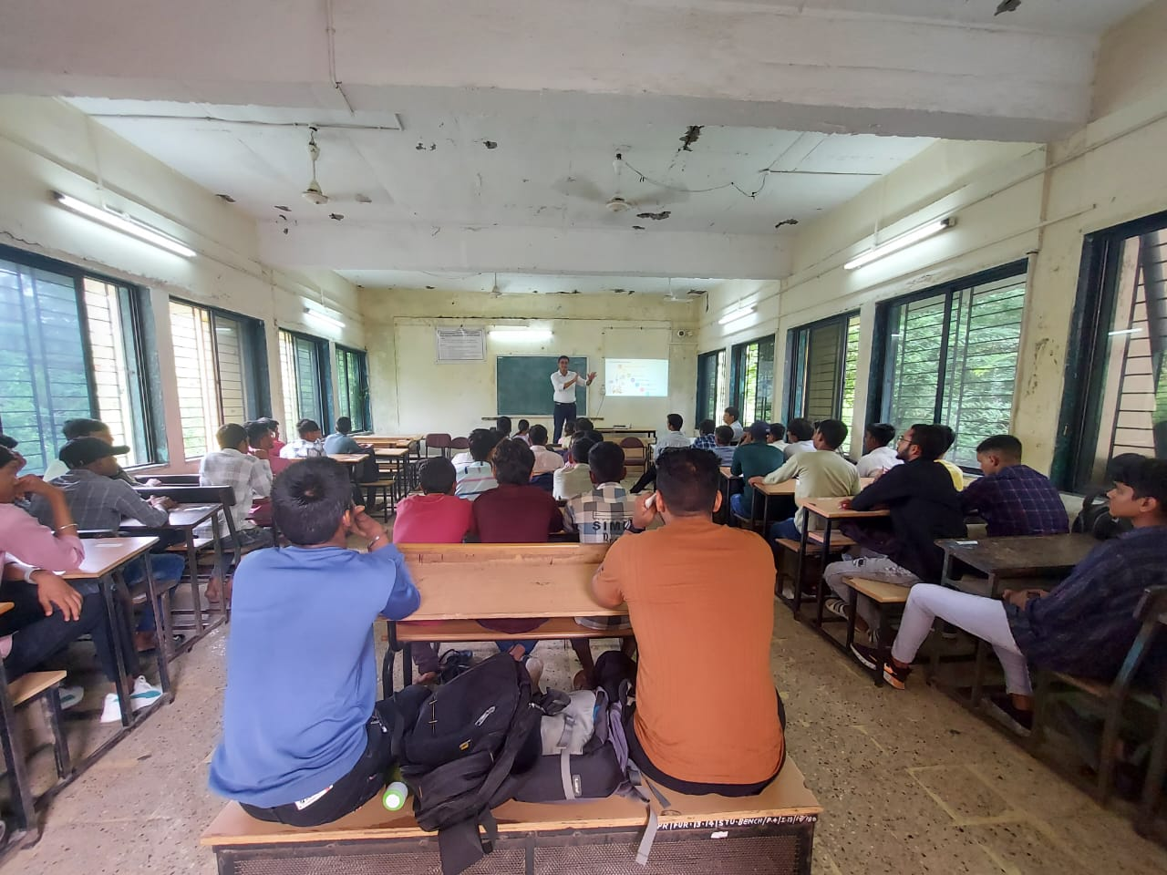

Mr. Pipaliya's adept presentation style facilitated interaction. He introduced SSIP 2.0, emphasizing its features, objectives, and role in promoting student-led startups. He underscored the significance of translating ideas into feasible ventures. Mr. Pipaliya elaborated on SSIP 2.0's advantages, such as funding, mentorship, and incubation support. The interactive session encouraged students to seek clarifications, benefitting from Mr. Pipaliya's expert insights. Real-world success stories illustrated SSIP 2.0's impact, inspiring attendees by showcasing innovation in action. The speaker highlighted the policy's empowerment of students to become self-reliant entrepreneurs, urging them to leverage its resources for their ideas.

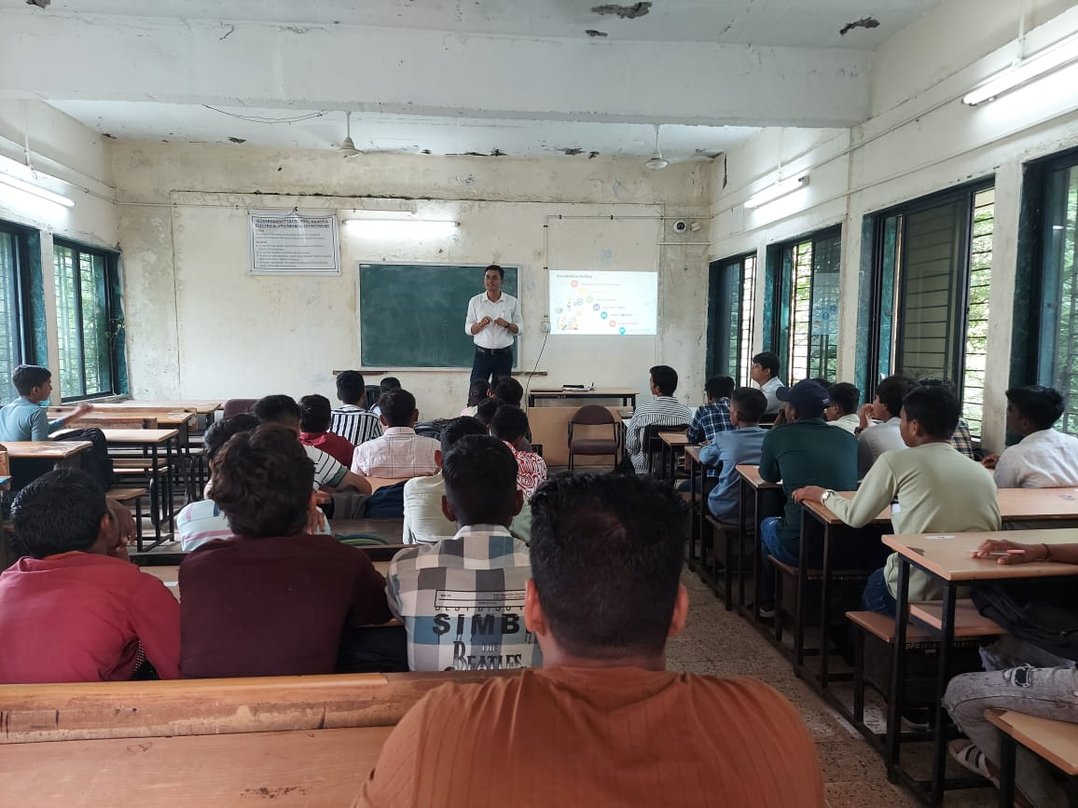

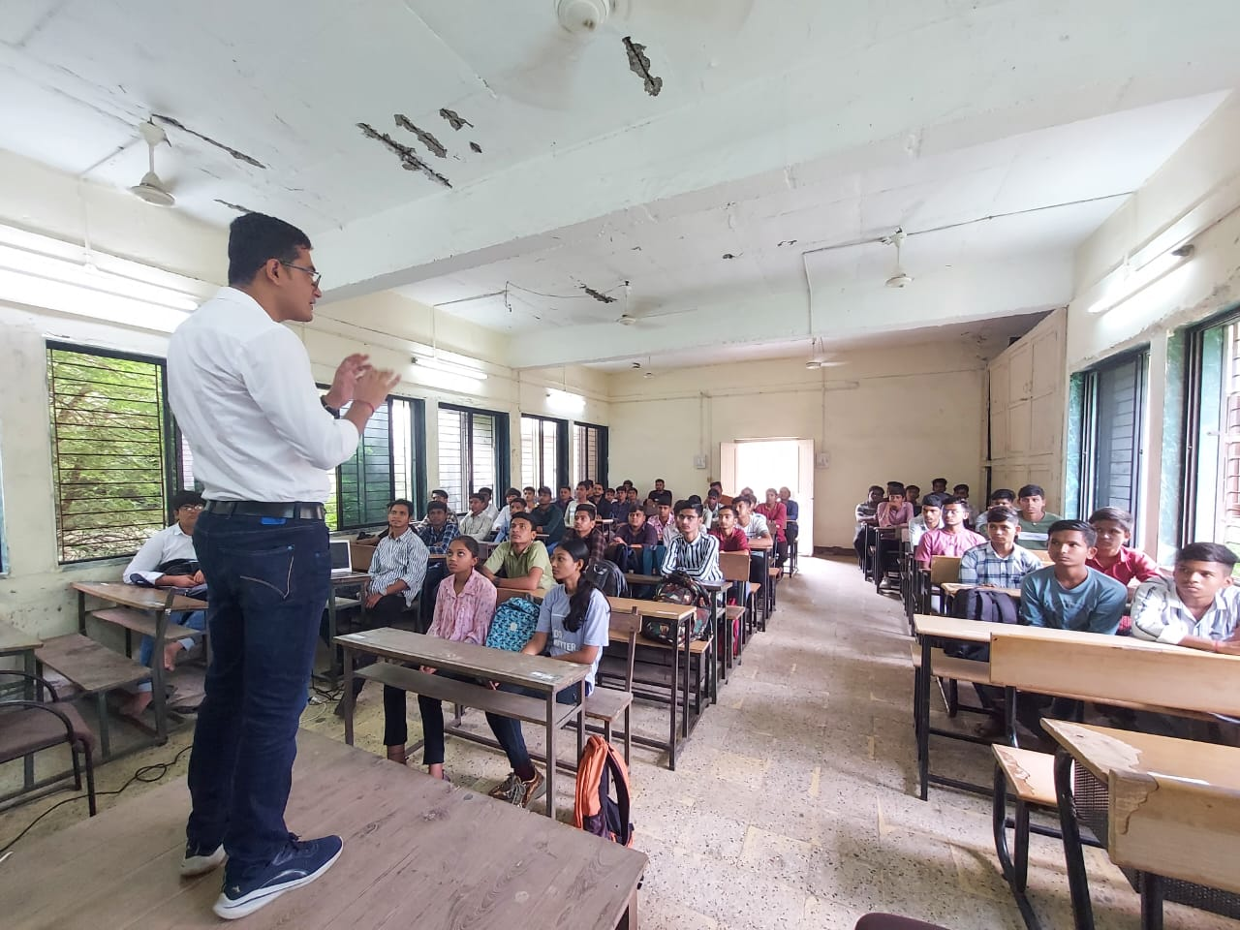

The sensitization event at Government Polytechnic Rajpipla marked a significant stride in cultivating an entrepreneurial mindset. Led by Mr. R.M. Pipaliya, the session informed students about SSIP 2.0's potential to shape their entrepreneurial aspirations. The event concluded with optimism that the knowledge gained would catalyze innovative pursuits and contribute to the startup ecosystem's growth.

